We found a vulnerability in FFmpeg-4.2-git. The source code was downloaded from github ( https://github.com/FFmpeg/FFmpeg.git ). This vulnerability can cause buffer overflow and lead to the corruption of FFmpeg. The command executed in Ubuntu-18.04 is:

ffmpeg –f image2 –i tiff xx.mpg

The execution path of corruption is shown as Figure 1:

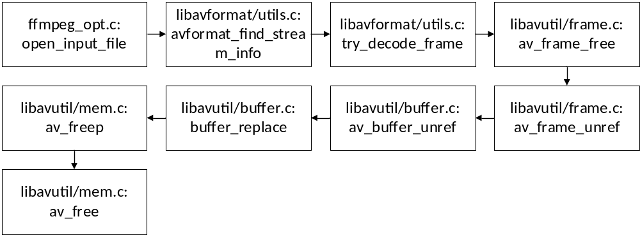
Figure 1

In libavutil/mem.c:av_freep(*arg) , the value of arg is 0xFFFFFFFFFFF , and the program shows that it is invalid pointer. The arg gets the value through the execution as the path shown in Figure 2:
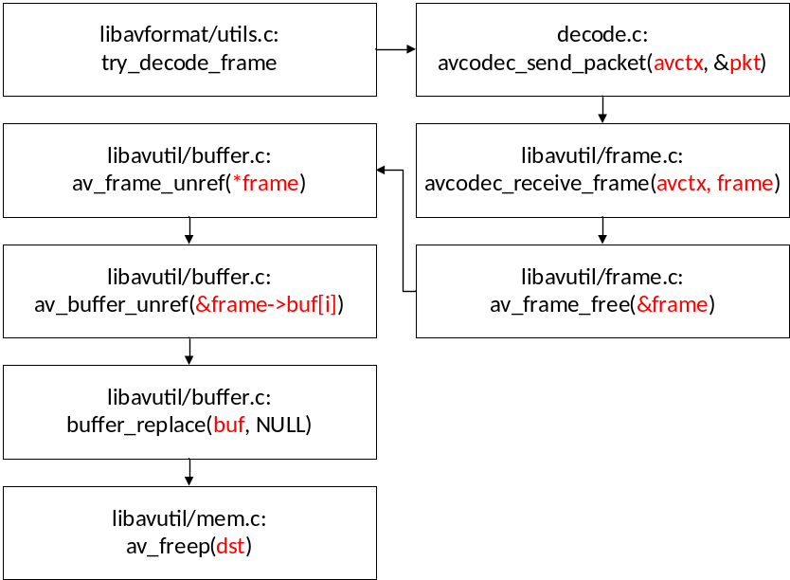
Figure 2

The arguments which are red means the data flow of tainted data.
According to our analysis, the layout of memory block is shown as Figure 3 when the program corrupted.

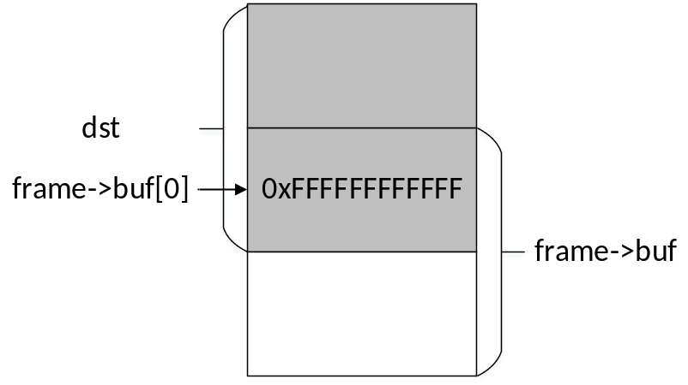
Figure 3

We can clearly see that the data in dst is overflow and overwrite the frame->buf which lead to the error of chunk free. Then we found the execution path of the creation and assignment of dst, shown as Figure 4.
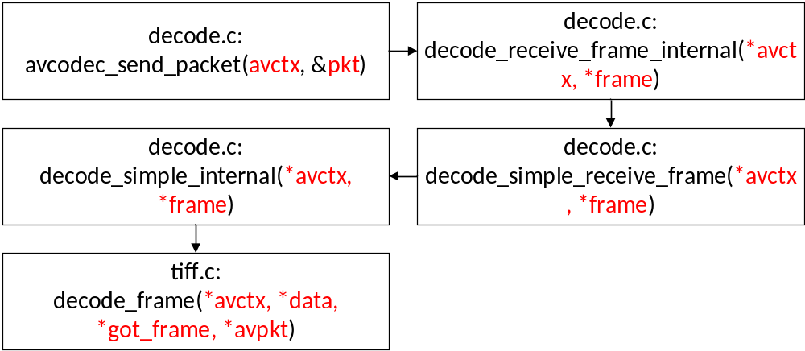
Figure 4

There may be more than one dst block ctreated in tiff.c: decode_frame( ), the number of dst blocks is determined by the tiff file. In the meanwhile, the size of each dst is determined stride which is also defined in function decode_frame( ), shown as Figure 5.

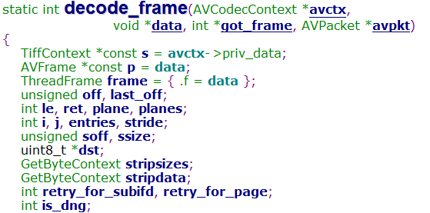
Figure 5

However, the length that each dst written is determined by another value. This operation is finished in function tiff.c: tiff_unpack_strip(*s, *p, *dst, stride, *src, size, strip_start, lines). As shown in Figure 6.

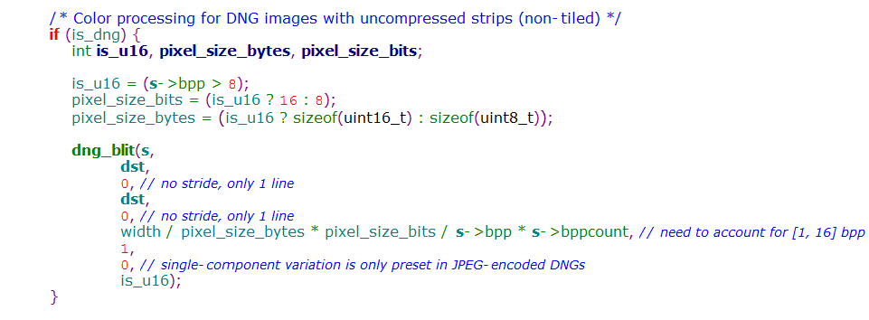
Figure 6

The length that each dst written can be expressed by the following expressions:

width = ((s->width * s->bpp) + 7) >> 3 (1)
is_u16 = (s->bpp > 8); (2)
pixel_size_bits = (is_u16 ? 16 : 8); (3)
pixel_size_bytes = (is_u16 ? sizeof(uint16_t) : sizeof(uint8_t)); (4)
length = width / pixel_size_bytes * pixel_size_bits / s->bpp * s->bppcount (5)

In the expressions above, some values are obtained through the decoding of tiff file. They are assigned in function tiff_decode_tag ( TiffContext *s, AVFrame *frame ).

s->width: When the DN tag = 0x100, FFmpeg will recognize it as the width of tiff.

s->bpp, s->bppcount: They obtained values from segment that DN tag = 0x115 in tiff file.

To sum up, if the length, which is shown in equation (5), is greater than stride, and the number of dst blocks is less than 10, it will lead to a buffer overflow vulnerability and the corruption of FFmpeg program.

In order avoid this risk, we suggest to add a check in function tiff.c: dng_blit(). Users cannot execute the write operation of dst blocks if length > stride.

The eg_crash is the PoC file of this vulnerability.

